|  |  |
| --- | --- |
| NAME: _____________ | **Statistics** |
| Sampling – BreastFeeding | **DATE: Monday, April 03, 2017** |

Example:

*For a final project, Hawa asks 80 randomly selected students if they believe in God. Of the 80, 78% say they do. Create a 95% confidence interval for the true proportion of all students who believe in God.*

1. **find the standard deviation:**



The standard deviation is 4.6%. This means if Hawa asked many other groups of 80 students, the percent of God believers she finds would vary on average about 4.6%.

Now, we know if we sample 80 students many times, the distribution would look like a bell curve (be normally distributed). In a normal distribution, 95% of the time, the percent of God believers would vary by at most 2 standard deviations.

**2. To find our 95% confidence interval, add and subtract 2 standard deviations from 78%.**



So we are 95% confident that the percent of ALL students that are God believers is between 77.8% and 87.2%

Practice

|  |  |
| --- | --- |
| Kim wants to know what % of people eat fast food. She asked 300 people in Portland, if they ate fast food in last week. 68% said yes. Create a 95% confidence interval our confidence interval for percent of ALL of Portland that ate fast food in last week. | We took a survey in Deering to find out if people want a later arrival time. In our survey of 120 students, 45% said they did. Create a 95% confidence interval our confidence interval for percent of ALL students who want a later start time. |

On your own, go to our website and click BreastFeeding and put your information below:

|  |  |  |  |  |  |
| --- | --- | --- | --- | --- | --- |
| Trial | Breastfeeding | Total | % BreastFeed | Standard Deviation | Confidence Interval for 95% confidence |
|  |  |  |  |  |  |
|  |  |  |  |  |  |
|  |  |  |  |  |  |
|  |  |  |  |  |  |
|  |  |  |  |  |  |

Graph all 5 of them below:

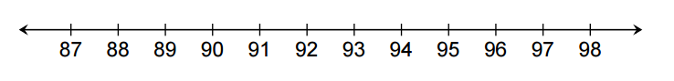

**In groups of 4:**

Which interval is the smallest?

Why do you think it’s the smallest?

Looking at all these intervals, what is your guess for the true proportion of mothers (in the system) that breastfeed?

After I announce the true answer, how many of your intervals contained the true proportion?